Week 2 - Movement, Looks, and Timing
Exercise is on Page 3

There are several ways to move a sprite in Scratch. Here are some of the main ones
Absolute Movement
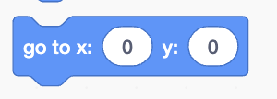 | Immediately move sprite to x, y 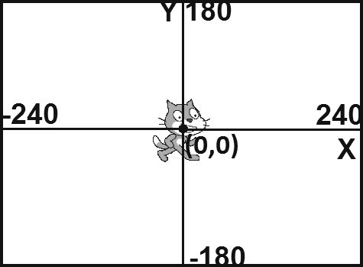
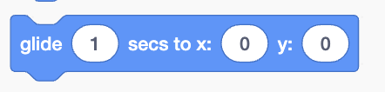 | Smoothly move sprite to x, y in a certain amount of time
   | Immediately go to particular x, y positions. Options include “random”, “mouse pointer”, and other sprites’ location.
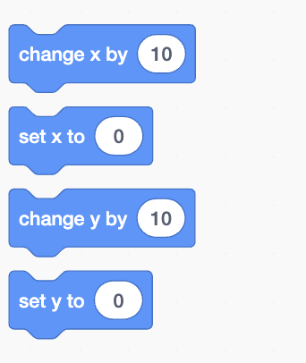 | Change x or y by the specified amount (note that you can change by a negative number)  or set JUST the x/y value to a particular value (also can be negative)
Turning and Relative Movement
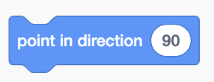 | Point the sprite in a particular direction. -90 is also 270. 0 is also 360 cuz it’s, like, a circle ya know?  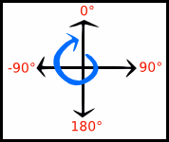
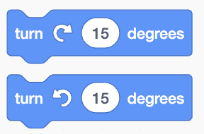 | Turn the sprite clockwise or counter-clockwise by a particular amount.
 | Move the sprite some amount in whatever direction it’s currently facing.

Looks
 | Make the sprite appear or disappear
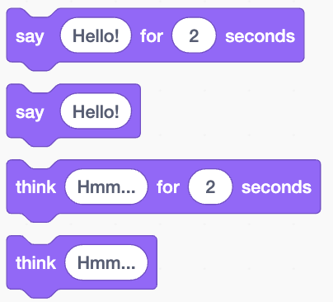 | Have the Sprite say or think something, either for a little while or forever.
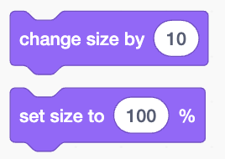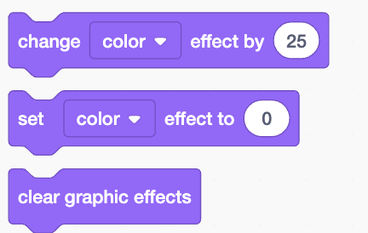 | Grow or shrink the sprite. Or change the sprite in other crazy ways (colors! pixelate! whirl!).
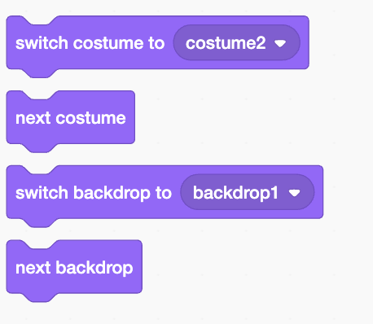 | Change the sprite’s costume. These are set up in a different tab once you have the sprite selected. This can be useful for creating animated sprites.  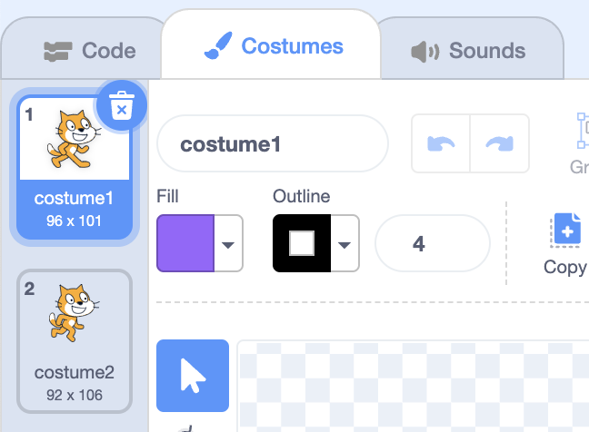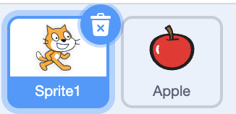
 | Change the background. These are set up in a different tab once you select “Stage” in the lower right.  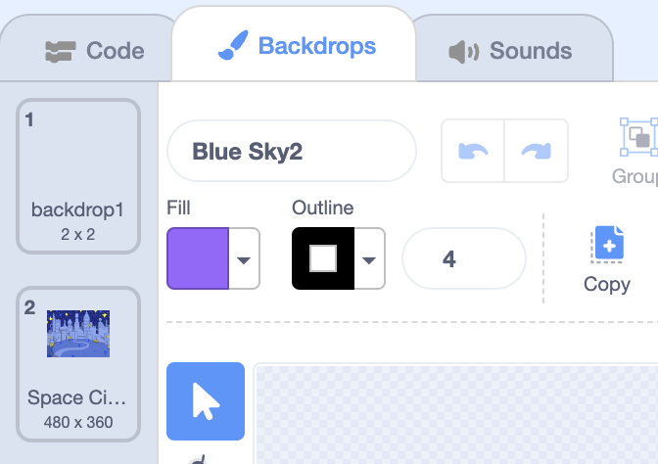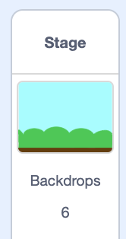

Events and Control
 | Events control everything in Scratch. Nothing happens without an event. The “when flag clicked” event determines what happens when the game/animation starts.
 | The most basic form of control in Scratch is just pausing the program for some amount of time.

Challenge
Make an “animated short” that …
- Has a story that “makes sense”--all of the following should be part of the story somehow
- Has at least two sprites
- Includes at least one noticeable costume change
- Includes at least one background change
- Involves dialogue between the two sprites (things they say or think should stay on the screen long enough to be read, and not much longer)
- Has a sprite suddenly appear at a particular location
- Has a sprite disappear
- Has a sprite glide from one part of the screen to another
- Has a sprite suddenly “teleport” from one place to another
- Has a sprite spin around
- Has a sprite change size and/or another aspect of appearance (color, effects) and then change back to normal

